Bahria University,

Karachi Campus



LAB EXPERIMENT NO.

**03**

LIST OF TASKS

|  |  |
| --- | --- |
| TASK NO | OBJECTIVE |
| 1 | Where (to which window) is the output data displayed? |
| 2 | Write down the address of the first instruction of the program (see the text window) |
| 3 | Write down the value of the register **$sp** just before you start the program. |
| 4 | Write down the values of $a0 and $v0 after execution in Register window and why? |
| 5 | Write an assembly program that Read and Print character. |
|  |  |
|  |  |
|  |  |

Submitted On:

Date: 24/10/2022

**Task No. 1:** Where (to which window) is the output data displayed?

**Output:**

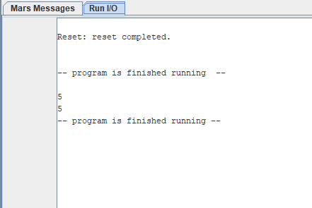

**Task No. 2:** Write down the address of the first instruction of the program (see the text window)

**Output:**

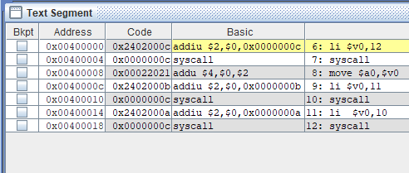

**Task No. 3:** Write down the value of the register **$sp** just before you start the program.

**Output:**

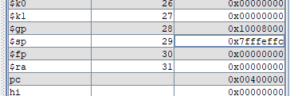

**Task No. 4:** Write down the values of $a0 and $v0 after execution in Register window and why?

**Output:**

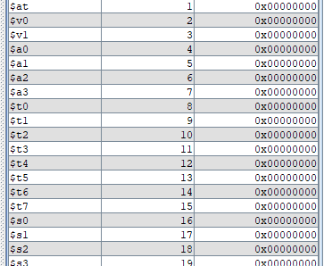

**Task No. 5:** Write an assembly program that Read and Print character.

**Source Code:**

.data

First : double 5.7

.text

.globl main

li $v0,12

syscall

move $a0,$v0

li $v0,11

syscall

li $v0,10

**Output:**

